Section 5_1 dbms

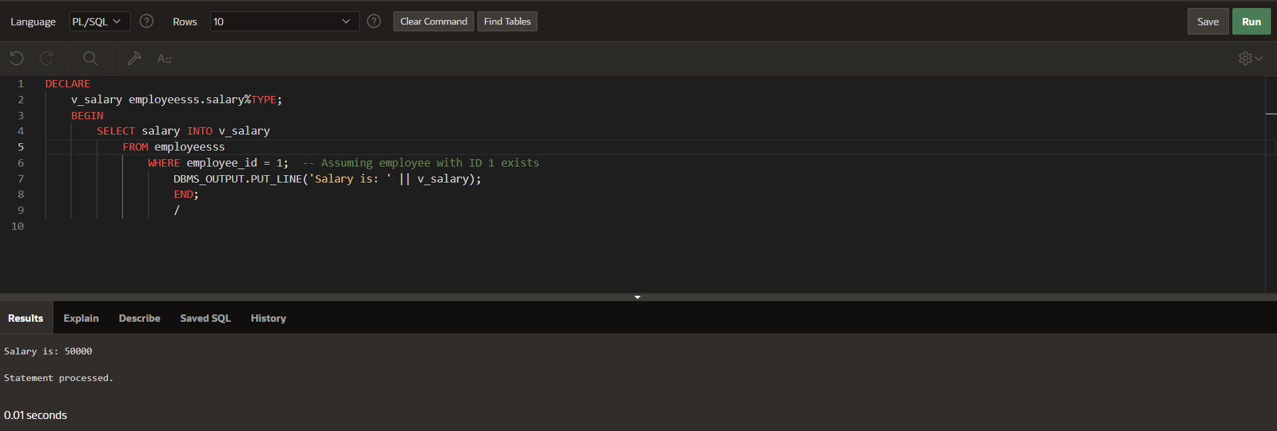

DECLARE

CURSOR cur_depts IS

SELECT department_id, department_name FROM departmentss;

v_department_id departmentss.department_id%TYPE;

v_department_name departmentss.department_name%TYPE;

BEGIN

OPEN cur_depts;

LOOP

FETCH cur_depts INTO v_department_id, v_department_name;

EXIT WHEN cur_depts%NOTFOUND;

DBMS_OUTPUT.PUT_LINE(v_department_id || ' ' || v_department_name);

END LOOP;

CLOSE cur_depts;

END;

/

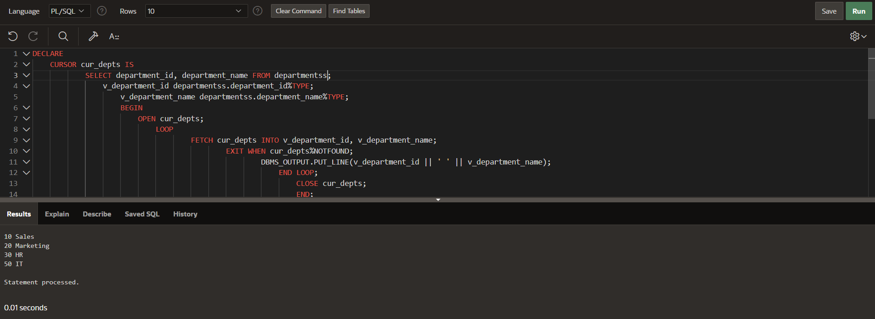

DECLARE

CURSOR emp_cursor IS

SELECT employee_id, last_name FROM employeesss

WHERE department_id = 10;

v_empno employeesss.employee_id%TYPE;

v_lname employeesss.last_name%TYPE;

BEGIN

OPEN emp_cursor;

FETCH emp_cursor INTO v_empno, v_lname;

DBMS_OUTPUT.PUT_LINE(v_empno || ' ' || v_lname);

CLOSE emp_cursor;

END;

/

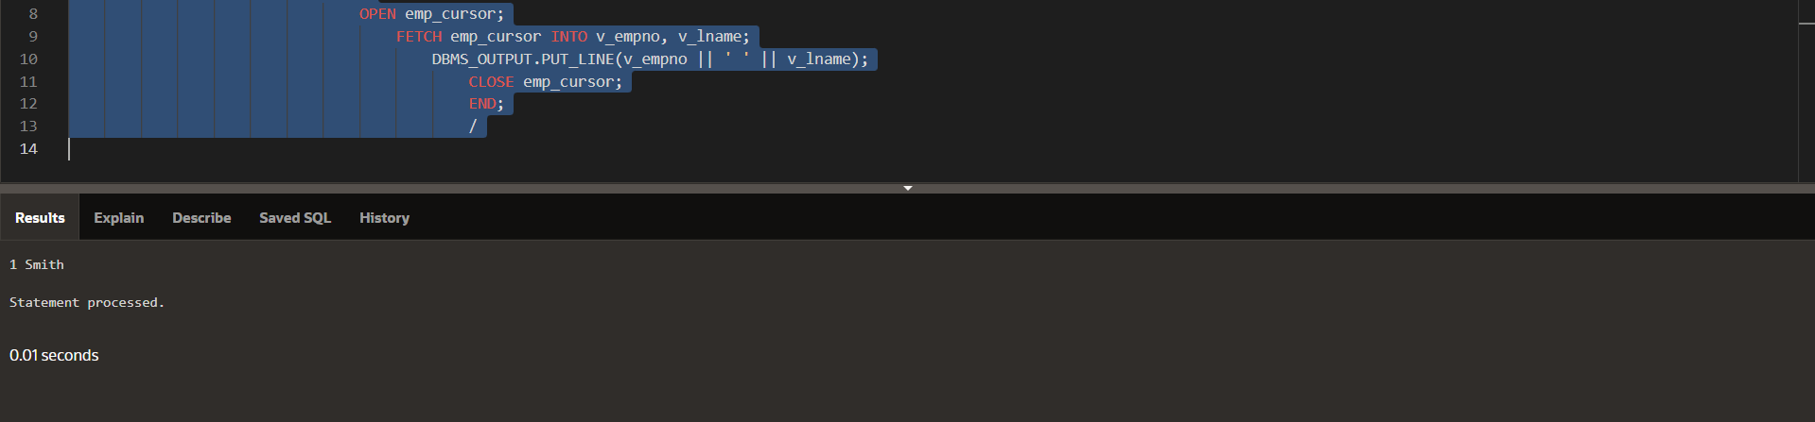

DECLARE

CURSOR cur_emps IS

SELECT employee_id, last_name FROM employeesss

WHERE department_id = 50;

v_empno employeesss.employee_id%TYPE;

v_lname employeesss.last_name%TYPE;

BEGIN

OPEN cur_emps;

LOOP

FETCH cur_emps INTO v_empno, v_lname;

EXIT WHEN cur_emps%NOTFOUND; -- exit loop when NOTFOUND is TRUE

DBMS_OUTPUT.PUT_LINE(v_empno || ' ' || v_lname);

END LOOP;

CLOSE cur_emps;

END;

/

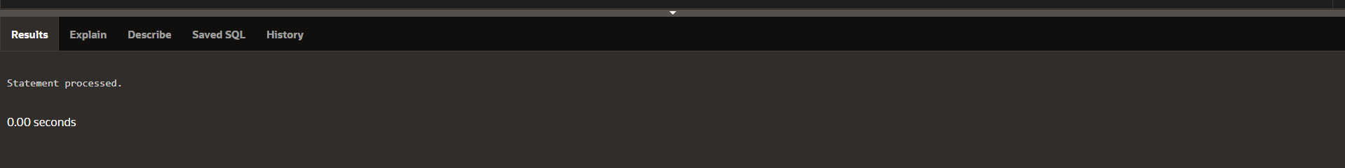

DECLARE

CURSOR cur_emps IS

SELECT employee_id, last_name FROM employeesss

WHERE department_id = 10;

v_empno employeesss.employee_id%TYPE;

BEGIN

OPEN cur_emps;

LOOP

FETCH cur_emps INTO v_empno, v_lname;

EXIT WHEN cur_emps%NOTFOUND;

DBMS_OUTPUT.PUT_LINE(v_empno || ' ' || v_lname);

END LOOP;

CLOSE cur_emps;

END;

/

_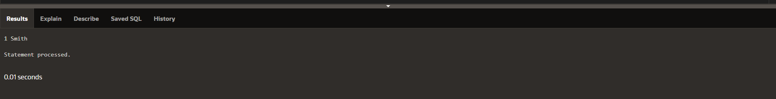

Section 5_2

DECLARE

CURSOR cur_emps IS

SELECT * FROM employeesss

WHERE department_id = 30;

v_emp_record cur_emps%ROWTYPE;

BEGIN

OPEN cur_emps;

LOOP

FETCH cur_emps INTO v_emp_record;

EXIT WHEN cur_emps%NOTFOUND;

DBMS_OUTPUT.PUT_LINE(v_emp_record.employee_id || ' - '

|| v_emp_record.last_name);

END LOOP;

CLOSE cur_emps;

END;

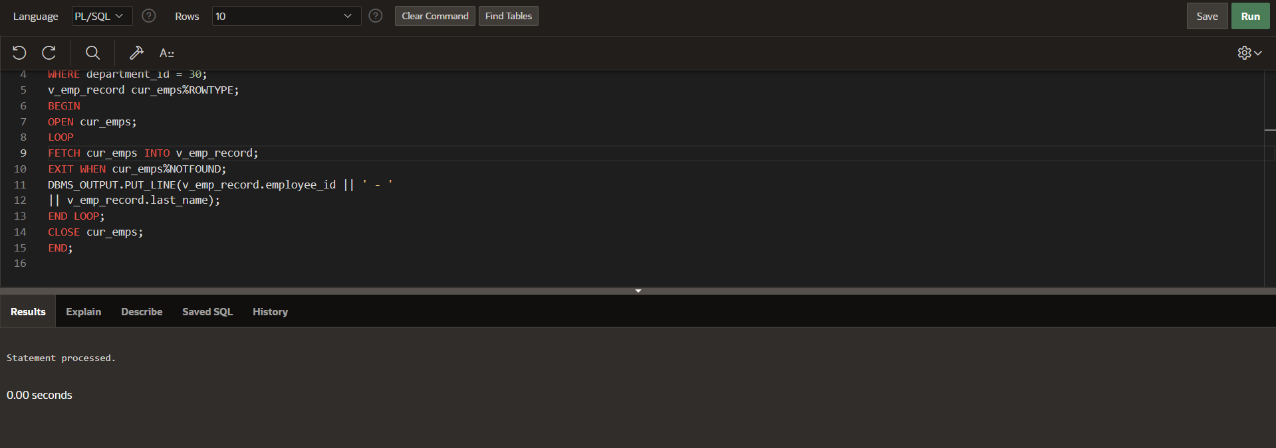

-- First PL/SQL Block

DECLARE

CURSOR cur_emps_dept IS

SELECT first_name, last_name, department_name

WHERE e.department_id = d.department_id;

v_emp_dept_record cur_emps_dept%ROWTYPE;

BEGIN

OPEN cur_emps_dept;

LOOP

FETCH cur_emps_dept INTO v_emp_dept_record;

EXIT WHEN cur_emps_dept%NOTFOUND;

DBMS_OUTPUT.PUT_LINE(v_emp_dept_record.first_name || ' – ' ||

v_emp_dept_record.last_name || ' – ' ||

v_emp_dept_record.department_name);

END LOOP;

CLOSE cur_emps_dept;

END;

/

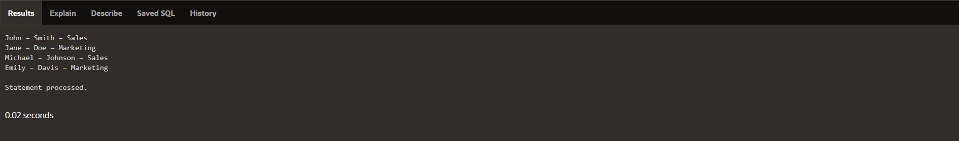

-- Second PL/SQL Block

DECLARE

CURSOR cur_emps IS

SELECT employee_id, last_name FROM emp ;

v_emp_record cur_emps%ROWTYPE;

BEGIN

OPEN cur_emps;

LOOP

FETCH cur_emps INTO v_emp_record;

EXIT WHEN cur_emps%ROWCOUNT > 10 OR cur_emps%NOTFOUND;

DBMS_OUTPUT.PUT_LINE(v_emp_record.employee_id || ' ' || v_emp_record.last_name);

END LOOP;

CLOSE cur_emps;

END;

/

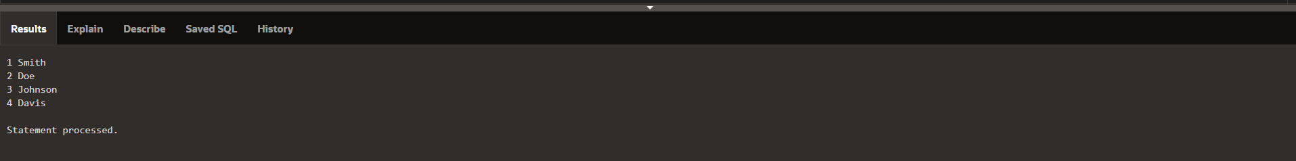

Section 5_3

DECLARE

CURSOR cur_emps IS

SELECT employee_id, last_name FROM emp

WHERE department_id = 50;

BEGIN

FOR v_emp_record IN cur_emps LOOP

DBMS_OUTPUT.PUT_LINE(v_emp_record.employee_id || ' '

|| v_emp_record.last_name);

END LOOP;

END;

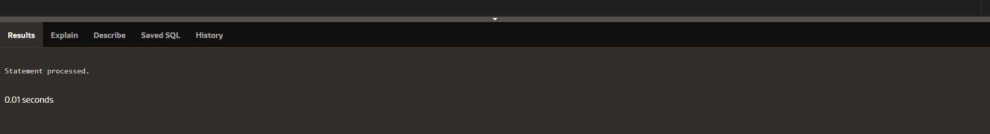

DECLARE

CURSOR cur_depts IS

SELECT department_id, department_name

FROM dep

ORDER BY department_id;

BEGIN

FOR v_dept_record IN cur_depts LOOP

DBMS_OUTPUT.PUT_LINE(v_dept_record.department_id || ' '

|| v_dept_record.department_name);

END LOOP;

END;

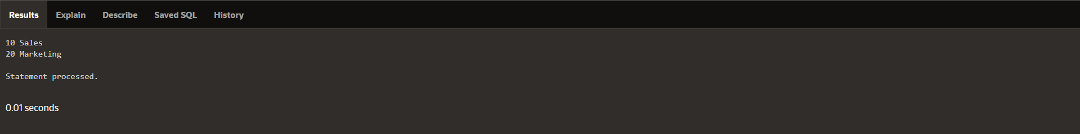

DECLARE

CURSOR cur_emps IS

SELECT employee_id, last_name

FROM employees;

BEGIN

FOR v_emp_record IN cur_emps LOOP

EXIT WHEN cur_emps%ROWCOUNT > 5;

DBMS_OUTPUT.PUT_LINE(v_emp_record.employee_id || ' ' ||

v_emp_record.last_name);

END LOOP;

END;

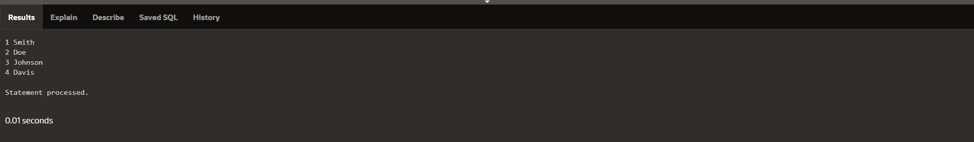

**Section 5_4**

**-- PL/SQL Block 1**

**DECLARE**

**CURSOR cur_country (p_region_id NUMBER) IS**

**SELECT country_id, country_name**

**FROM countries**

**WHERE region_id = p_region_id;**

**v_country_record cur_country%ROWTYPE;**

**BEGIN**

**OPEN cur_country(145);**

**LOOP**

**FETCH cur_country INTO v_country_record;**

**EXIT WHEN cur_country%NOTFOUND;**

**DBMS_OUTPUT.PUT_LINE(v_country_record.country_id || ' ' || v_country_record.country_name);**

**END LOOP;**

**CLOSE cur_country;**

**END;**

**/**

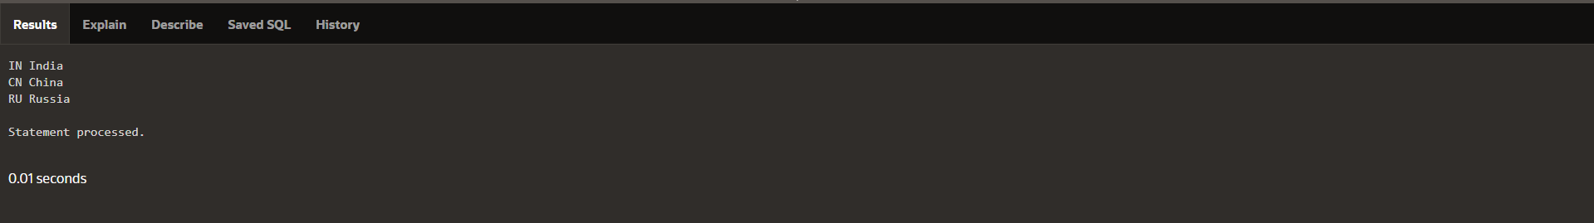

**-- PL/SQL Block 2**

**DECLARE**

**v_deptid employees.department_id%TYPE;**

**CURSOR cur_emps (p_deptid NUMBER) IS**

**SELECT employee_id, salary**

**FROM employees**

**WHERE department_id = p_deptid;**

**v_emp_rec cur_emps%ROWTYPE;**

**BEGIN**

**SELECT MAX(department_id) INTO v_deptid**

**FROM employees;**

**OPEN cur_emps(v_deptid);**

**LOOP**

**FETCH cur_emps INTO v_emp_rec;**

**EXIT WHEN cur_emps%NOTFOUND;**

**DBMS_OUTPUT.PUT_LINE(v_emp_rec.employee_id || ' ' || v_emp_rec.salary);**

**END LOOP;**

**CLOSE cur_emps;**

**END;**

**/\**

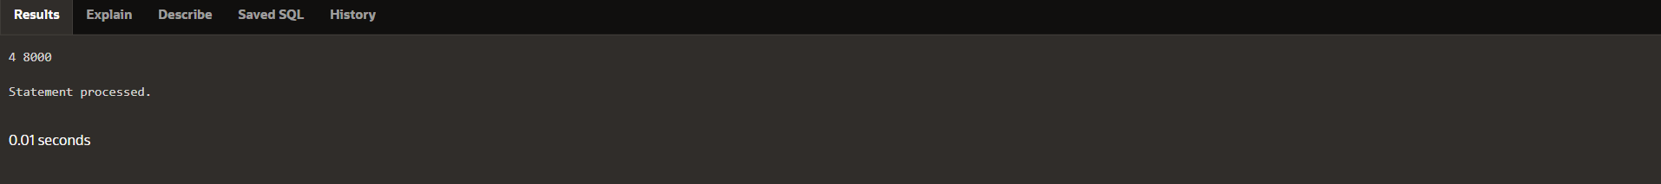

**-- PL/SQL Block 3**

**DECLARE**

**CURSOR cur_emps (p_job VARCHAR2, p_salary NUMBER) IS**

**SELECT employee_id, last_name**

**FROM empl**

**WHERE job_id = p_job**

**AND salary > p_salary;**

**BEGIN**

**FOR v_emp_record IN cur_emps('IT_PROG', 10000) LOOP**

**DBMS_OUTPUT.PUT_LINE(v_emp_record.employee_id ||' ' || v_emp_record.last_name);**

**END LOOP;**

**END;**

**/**

**\**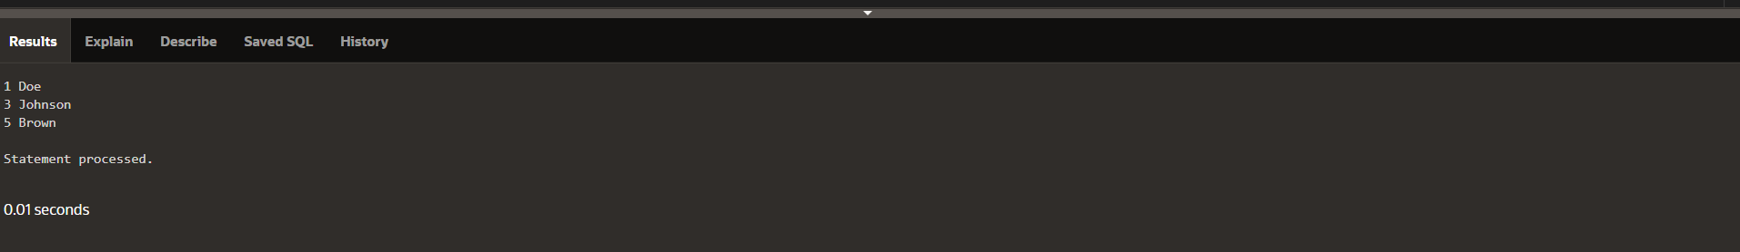

**-- PL/SQL Block 4**

**DECLARE**

**CURSOR cur_countries (p_region_id NUMBER, p_population NUMBER) IS**

**SELECT country_id, country_name, population**

**FROM countries**

**WHERE region_id = p_region_id**

**OR population > p_population;**

**BEGIN**

**FOR v_country_record IN cur_countries(145, 10000000) LOOP**

**DBMS_OUTPUT.PUT_LINE(v_country_record.country_id ||' ' || v_country_record.country_name || ' ' || v_country_record.population);**

**END LOOP;**

**END;**

**/**



**Section 5_5**

**DECLARE**

**CURSOR cur_emps IS**

**SELECT employee_id, salary FROM empl**

**WHERE salary <= 20000 FOR UPDATE NOWAIT;**

**v_emp_rec cur_emps%ROWTYPE;**

**BEGIN**

**OPEN cur_emps;**

**LOOP**

**FETCH cur_emps INTO v_emp_rec;**

**EXIT WHEN cur_emps%NOTFOUND;**

**UPDATE empl**

**SET salary = v_emp_rec.salary*1.1**

**WHERE CURRENT OF cur_emps;**

**END LOOP;**

**CLOSE cur_emps;**

**END;**

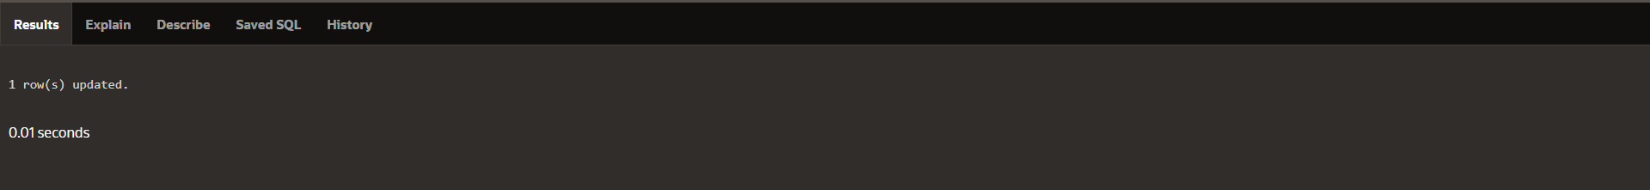

**DECLARE**

**CURSOR cur_loc IS SELECT * FROM locations;**

**CURSOR cur_dept (p_locid NUMBER) IS**

**SELECT * FROM departmente WHERE location_id = p_locid;**

**v_locrec cur_loc%ROWTYPE;**

**v_deptrec cur_dept%ROWTYPE;**

**BEGIN**

**OPEN cur_loc;**

**LOOP**

**FETCH cur_loc INTO v_locrec;**

**EXIT WHEN cur_loc%NOTFOUND;**

**DBMS_OUTPUT.PUT_LINE(v_locrec.city);**

**OPEN cur_dept (v_locrec.location_id);**

**LOOP**

**FETCH cur_dept INTO v_deptrec;**

**EXIT WHEN cur_dept%NOTFOUND;**

**DBMS_OUTPUT.PUT_LINE(v_deptrec.department_name);**

**END LOOP;**

**CLOSE cur_dept;**

**END LOOP;**

**CLOSE cur_loc;**

**END;**

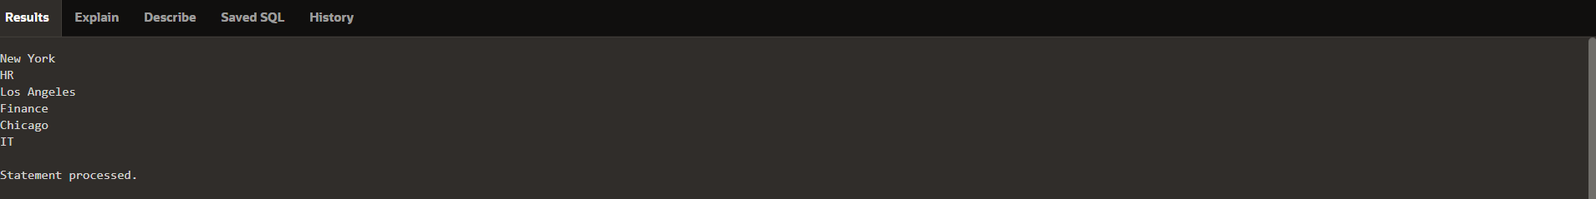

**DECLARE**

**CURSOR cur_loc IS SELECT * FROM locations;**

**CURSOR cur_dept (p_locid NUMBER) IS**

**SELECT * FROM departmente WHERE location_id = p_locid;**

**BEGIN**

**FOR v_locrec IN cur_loc LOOP**

**DBMS_OUTPUT.PUT_LINE(v_locrec.city);**

**FOR v_deptrec IN cur_dept (v_locrec.location_id) LOOP**

**DBMS_OUTPUT.PUT_LINE(v_deptrec.department_name);**

**END LOOP;**

**END LOOP;**

**END;**

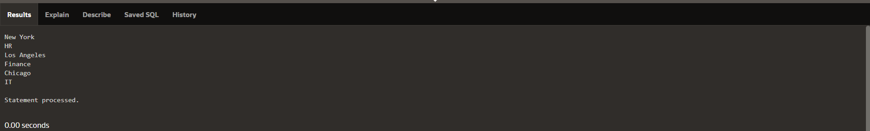

**DECLARE**

**CURSOR cur_dept IS SELECT * FROM departmente;**

**CURSOR cur_emp (p_dept_id NUMBER) IS**

**SELECT * FROM employeese WHERE department_id = p_dept_id**

**FOR UPDATE NOWAIT;**

**BEGIN**

**FOR v_deptrec IN cur_dept LOOP**

**DBMS_OUTPUT.PUT_LINE(v_deptrec.department_name);**

**FOR v_emprec IN cur_emp (v_deptrec.department_id) LOOP**

**DBMS_OUTPUT.PUT_LINE(v_emprec.last_name);**

**IF v_deptrec.location_id = 1 AND v_emprec.salary < 10000 THEN**

**UPDATE employeese**

**SET salary = salary * 1.1**

**WHERE CURRENT OF cur_emp;**

**END IF;**

**END LOOP;**

**END LOOP;**

**END;**

